**Deoancă Raluca Bianca** – heading 1,font color:purple, text bold

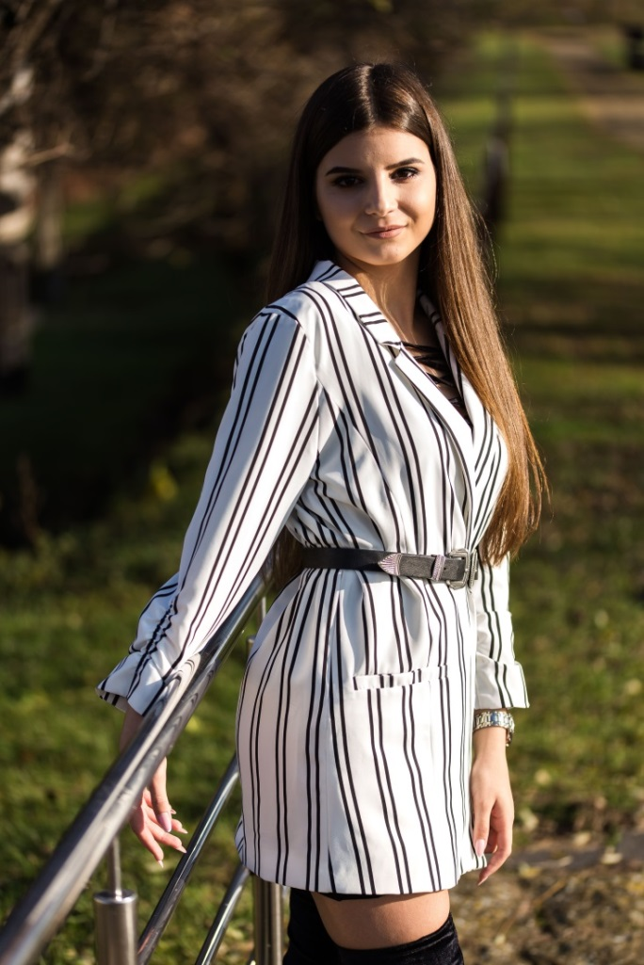 -imagine,picture border:dark blue

**Descriere:** Studenta ETTI-anul I – paragraf , font color:purple,font-family:Andalus

## **E-mail:** biancaralu@yahoo.com - heading 2, font color:purple

**Educatie: -**heading 2

|  |  |
| --- | --- |
| C.E. “Dionisie Pop Martian” | 2016-2020 |
| UTCN | 2020-prezent |

-tabel

“ Educatia e cea mai puternica arma pe care o poti folosi pentru a schimba lumea.”(Nelson Mandela) - paragraf

**Discipline:** -heading 2 ,text bold, font color:purple

* Analiza matematica -element lista
* Programarea Calculatoarelor -element lista
* Informatica Aplicata -element lista

**Link disciplina: -**heading 2, text bold, font color:purple

* <https://etti.utcluj.ro/files/FiseDisciplina/EaRo/01.pdf-Analiza> matematica -element lista
* <https://etti.utcluj.ro/files/FiseDisciplina/EaRo/04.pdf-Programarea> Calculatoarelor -element lista
* <https://etti.utcluj.ro/files/FiseDisciplina/EaRo/06.pdf-> Informatica Aplicata -element lista

**Pasiuni: -**heading 2, font color:purple

|  |
| --- |
| * Imi place sa calatoresc -element lista * Imi place sa citesc -element lista * Imi place sa desenez -element lista |

## -tabel